Match the photos of traditional dishes to the country.

1. 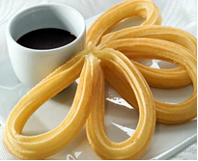 Churros with Chocolate/Spanish doughnut with chocolate
2. Spain
3. Italy
4. Poland
5. Romania

Answer: a

1. 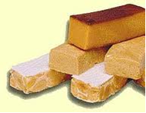 Turrón, Traditional Christmas Sweet/Spanish Almond candy/nougat
2. Italy
3. Spain
4. Bulgaria
5. Turkey

Answer: b

1. 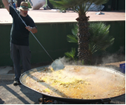 PAELLA/Valencian rice dish
2. Spain
3. Turkey
4. Italy
5. Poland

Answer: a

1. 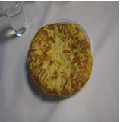 Spanish omelette/Tortilla
2. Italy
3. Turkey
4. Romania
5. Spain

Anwer: d

1. 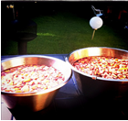 SANGRÍA/Wine punch
2. Spain
3. Turkey
4. Bulgaria
5. Romania

Answer: a